Sankey Diagrams
Name: ____________________________ Class: _______
Sankey diagrams show how energy is changed by a device. The wider the arrow, the more energy is flowing in that direction. Arrows that continue to travel to the right show useful forms of energy. Arrows that diverge downwards show the forms of wasted energy.
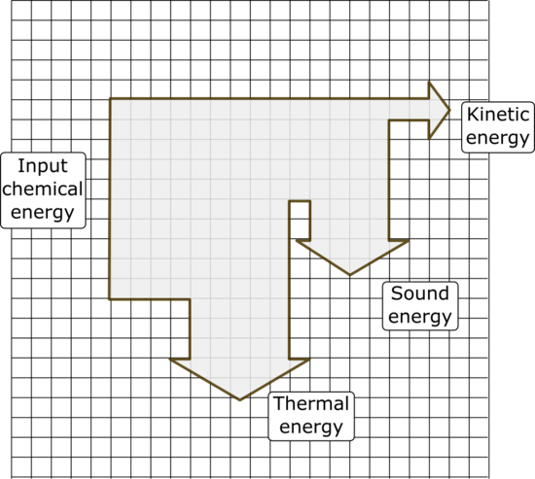
This Sankey Diagram shows the energy input and output for an old diesel car engine.
T1) In the above Sankey diagram every grid represent 10KJ (KiloJoules). Use the grid to calculate the following:
Input energy:
Chemical energy …..…….………
Total input energy =…………….KJ

Output energy:
Thermal energy ………..……..…
Sound Energy ………..………
Kinetic energy ……….………
Total output energy =………..…KJ

Filling the missing words.
Energy can not be c……………..……… or d……..………. Energy can only c……………... from one t …….…… to another t……………. This is called the law of conservation of energy. First noticed by a scientist called A…………….……… E……….…………….
To complete this sheet successfully you will need to use a pencil and a rubber as you might make errors in drawing the energy Sankey diagrams correctly in the first attempt.
T2). Use the Sankey Diagram to calculate the useful energy transfer of an iPod. Every grid here is equal to 10 Joules (J) of energy.
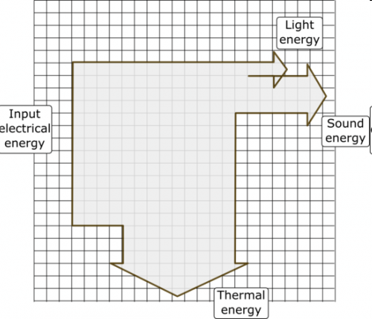
Input energy (energy that goes in)
…………………………………………………………………………………………………… …………… Total input energy….………(……….)
Output energy (energy that goes out)
……………………………………………………………………………………………………………………………………….…………………………………………
…………………………………………………………………………………………………………….……….……Total energy output(…………J)

T3) An electrical torch uses 100 Joules (J) of electrical energy to change it to 10 J of light energy and 90 J of heat energy. Use the grids below to sketch a sankey diagram for the torch. You need to decide each grid how many Joules it represents.

T4) Extension task ☺. A mobile phone transforms 110J of input chemical energy into 30J of sound energy, 30J of light energy, and 50 Joules of heat energy. Draw a Sankey diagram to present your data (you need to decide each grid how much Joules it represents).

T5) Decide by estimating how much electrical (input) energy goes into your computer when is being used. How much is the output energy (light, sound, heat). Draw a Sankey diagram in the graph below.

A saving energy light uses 12J of electrical input energy to give out 6J of light energy. How much wasted heat energy would a fluorescent bulb give out? Draw a Sankey diagram to show that.

T6)
An old car uses 1000 Joules (J) of chemical energy from the fuel to convert it into 350 J into sound energy, 500 J into heat energy, and the rest of the energy it transformed into useful kinetic energy. Sketch a Sankey diagram that will represent the old car’s energy transformations.

T7)
For each of the Sankey diagrams, calculate the efficiency of each system.

